CONVENTION FOR THE SAFEGUARDING OF THE
INTANGIBLE CULTURAL HERITAGE
INTERGOVERNMENTAL COMMITTEE FOR THE
SAFEGUARDING OF THE INTANGIBLE CULTURAL HERITAGE
Eighth session
Baku, Azerbaijan
2 to 7 December 2013
Item 5.c of the Provisional Agenda:
Report on the evaluation by the Internal Oversight Service of
UNESCO’s standard-setting work of the Culture Sector and the
related audit of the working methods of Cultural Conventions
Summary
The Internal Oversight Service has recently completed the first part of an evaluation of UNESCO’s standard-setting work of the Culture Sector, concerning the Convention for the Safeguarding of the Intangible Cultural Heritage, as well as an audit of the working methods of all six culture conventions. The present document introduces the reports on the evaluation and audit, summaries of which are annexed, and offers possible responses for the Committee’s consideration.
Decisions required: paragraph 9
- ln line with its biennial evaluation plan for 2012-13, UNESCO’s Internal Oversight Service (IOS) is currently conducting an evaluation of UNESCO’s standard-setting work of the Culture Sector, the first part of which concerns the Convention for the Safeguarding of the Intangible Cultural Heritage and has been completed, complemented by an audit of the working methods of all six cultural conventions, also completed. Preliminary findings were presented to the Executive Board at its 192nd session (Document 192 EX/5 Part II), which noted ‘the importance of improving the quality of causal analysis and evidence of impact brought about by UNESCO’s standard setting and normative work’, welcoming the evaluations and audit completed, and invited ‘the Director-General to implement the recommendations, except those recommendations that require a decision by the Executive Board and/or General Conference, in which case the relevant issue shall be submitted to the Executive Board for its consideration’ (192 EX/Decision 5 Part II).
- The purpose of the overall evaluation is to generate findings and recommendations regarding the relevance and the effectiveness of the standard‐setting work of the Culture Sector, with a focus on its impact on legislation, policies, and strategies of Parties to UNESCO’s culture conventions and on the implementation of the conventions at the national level. The evaluation aims to help to strengthen, refocus and better coordinate the Organization’s standard‐setting activities. The evaluation also seeks to contribute to generating a better understanding about how conventions work in practice and to serve as a source of information for Member States, who have the primary responsibility for the implementation of the standard‐setting instruments at the national level. The evaluation of the 2003 Convention is the first ever conducted for that Convention, and thus aims to inform UNESCO’s future efforts to promote its implementation, while feeding into the overall evaluation of standard‐setting work of the Culture Sector. (The corresponding evaluations of other culture conventions will be completed in late 2013 and early 2014.) The IOS report, ‘Evaluation of UNESCO’s Standard‐setting Work of the Culture Sector: Part I – 2003 Convention for the Safeguarding of the Intangible Cultural Heritage’ is available online (Document IOS/EVS/PI/129); its executive summary constitutes Annex I to the present document.
- In complement to the evaluation of the impact and effectiveness of the 2003 Convention, IOS also conducted an audit of the working methods of the six conventions in the field of culture, in order to assess the adequacy and efficiency of the working methods of UNESCO’s standard-setting work. The scope of the review included working methods of the convention secretariats, the funding arrangements and the meetings of the governing bodies. The IOS report, ‘Audit of the Working Methods of Cultural Conventions’ (Document IOS/AUD/2013/06), constitutes Annex II to the present document.
- Both the evaluation and the audit offer a number of informative observations and useful recommendations for consideration by the Secretariat, the Parties to the different conventions and their Governing Bodies, as well as the Member States of UNESCO and its Governing Bodies. The evaluation, coming as the Convention celebrates its first decade, offers a vision for its second decade and beyond, as well as a strategic orientation for helping the Convention to consolidate its achievements and realize its potential even more fully in the future. The audit is situated more in the immediate context of the present financial constraints faced by the Organization, the necessity to align the Secretariat’s workload with the available resources and the possibility to achieve cost savings through increased synergy and efficiency.
- As requested by the Executive Board in its 192 EX/Decision 5 Part II, the Director-General has consequently sought to outline an overall plan whereby these recommendations can be translated into action. Given the number of different actors and the respective competencies of the different organs, there are certain recommendations the Director-General and the Secretariat can implement immediately, others that fall within the authority of the Committee, while yet others would appropriately be the subject of recommendations by the Committee to the General Assembly. Several of the recommendations invite responses on the part of States Parties, non-governmental organizations, category 2 centres and other stakeholders.
- The eighth session of the Committee offers the appropriate and timely opportunity to take into account the findings and recommendations of the IOS studies. The Director-General therefore proposes two draft decisions for consideration by the Committee that respond to the recommendations of the evaluation and audit, respectively. Certain recommendations have also been reflected, where relevant, in the draft decisions concerning other agenda items during the present session. In her proposals, the Director-General has sought wherever possible to strengthen the effectiveness of the Convention through the concerted action of its many stakeholders, recognizing that the capacities of the Secretariat will not be expanded through growth in personnel or budget but instead through streamlining and rationalization of processes and increased cost efficiency. Most of the proposals aim at strategically reorienting existing resources and are therefore without budgetary implications; others indeed aim at cost-saving.
- Draft Decision 8.COM 5.c.1 refers to the recommendations in the evaluation. The draft decision proposes that the Committee encourage States Parties and other stakeholders involved in the implementation of the Convention to move forward with those recommendations where their role is crucial. Moreover, the draft decision addresses those recommendations of the evaluation pertaining to the Operational Directives that would require decisions, respectively, by the Committee and by the General Assembly at its fifth session in 2014, as well as some issues on which the Committee may wish to deliberate further in view of the General Assembly in 2016. Other provisions could be decided by the Committee or implemented by the Secretariat should the Committee so wish.
- Draft Decision 8.COM 5.c.2 similarly refers to the recommendations of the audit addressed to the various constituencies, i.e. the States Parties, the Committee, the General Assembly or the Secretariat with regard to the following topics: the creation of a dedicated sub-fund for voluntary supplementary contributions to the Convention; the application of existing policies consistently; and the synchronization of meetings of Parties of the respective culture conventions. It is to be noted that the Director-General has already initiated the implementation of some of these recommendations emanating from the IOS audit, notably with regard to the creation of the sub-fund.
- The Committee may wish to adopt the following decisions:
DRAFT DECISION 8.COM 5.c.1
The Committee,
- Having examined Document ITH/13/8.COM/5.c and its annex I, as well as the ‘Evaluation of UNESCO’s Standard‐setting Work of the Culture Sector: Part I – 2003 Convention for the Safeguarding of the Intangible Cultural Heritage’ (Document IOS/EVS/PI/129),
- Noting that the present evaluation constitutes the first such evaluation of the impact and effectiveness of the 2003 Convention,
- Welcomes the findings of the evaluation and the recommendations offered therein;
- Encourages States Parties to:
  - Promote increased NGO and community involvement in the development of policy, legislation, safeguarding plans and sustainable development plans (Recommendation 2);
  - Enhance cooperation with sustainable development experts for integrating intangible cultural heritage into non-cultural legislation, policy development and for other work related to intangible cultural heritage and sustainable development (Recommendation 3);
  - Strengthen monitoring and evaluation of the implementation of the Convention at the national level (Recommendation 24);
- Calls upon States Parties and the General Assembly, as well as the Secretariat, category 2 centres, non-governmental organizations and all other stakeholders, to:
  - Promote the Urgent Safeguarding List by re-positioning it as an expression of States Parties’ commitment to safeguarding and to the implementation of the Convention, and especially recognize those States Parties that submit nominations to the Urgent Safeguarding List (Recommendation 8);
  - Clarify all misconceptions regarding the purpose and use of the Representative List (Recommendation 9);
  - Complement the Register of Best Safeguarding Practices by developing alternate, lighter ways of sharing safeguarding experiences such as dedicated websites, e-newsletters, online forums, etc. (Recommendation 12);
  - Strengthen UNESCO’s long-standing cooperation with WIPO over traditional knowledge and culture to ensure an ongoing exchange and learning between the two organizations and their Member States, especially in the context of WIPO’s current discussions about a new international standard-setting instrument for the protection of the intellectual property rights of communities (Recommendation 15);
  - Encourage a debate on the role of the private sector and of private/public partnerships in safeguarding intangible cultural heritage at all levels (national, regional and international) in order to better define its potential for cooperation and involvement (Recommendation 19);
  - Strengthen informal sharing of interesting and innovative examples on working on the Convention, including about intangible cultural heritage safeguarding, development of policy and legislation, intangible cultural heritage and sustainable development, innovative partnerships and others (Recommendation 20);
- Recommends to the General Assembly to approve the amendments to the Operational Directives for the implementation of the Convention in order to:
  - Have all nominations evaluated by one common and independent Body (Recommendation 11);
  - Give priority to International Assistance requests within the ceiling of files to the Convention’s mechanisms (Recommendation 13);
  - Revise the accreditation process and criteria for NGOs to ensure that all accredited NGOs have the required experience and capacity to provide advisory services to the Committee (Recommendation 18);
- Requests the Secretariat to propose draft text of the Operational Directives accordingly concerning the points in Paragraph 6 of the present Decision and reflecting its debates during the present session, for examination by the General Assembly at its fifth session;
- Decides to:
  - Ensure that inscription of elements to the Representative List reflect more closely the criteria and procedures specified in Chapter I.2 of the Convention’s Operational Directives (Recommendation 10);
  - Encourage representatives of accredited NGOs to participate in Committee debates prior to voting on agenda items and include the outcomes of the NGO forums (such as the NGO Statements) in the Committee agendas (Recommendation 17);
- Further decides to:
  - Revise periodic reporting forms to include specific questions on policy, legislation and gender and to ensure that the reports focus on results rather than on activities (Recommendation 21);
  - Develop an overall results framework for the Convention, linked to a Convention theory of change and including clear objectives, time-frames, indicators and benchmarks (Recommendation 22);
  - Complement the data gathered on the implementation of the Convention through Periodic Reports submitted by States Parties with information provided by NGOs (Recommendation 23);
- Requests the Secretariat to propose draft text of the Operational Directives accordingly concerning the points in Paragraph 9 of the present Decision and reflecting its debates during the present session, for examination by the Committee at its ninth session;
- Further requests the Secretariat to:
  - Revise all relevant documents and forms (including the Operational Directives, the Periodic Reporting formats, and nomination files) to include gender-specific guidance and questions (Recommendation 1);
  - Support States Parties with the development of legislation and policy as part of the ongoing 2003 Convention capacity-building programme and design appropriate capacity-building formats to do so (Recommendation 4);
  - Cooperate with sustainable development experts when supporting State Parties with the integration of intangible cultural heritage into non-cultural legislation and policy, and with other work related to intangible cultural heritage and sustainable development (Recommendation 5);
  - Establish, with the full involvement of UNESCO field offices and in cooperation with UNESCO National Commissions, a follow-up mechanism for capacity-building activities to gather data about their effectiveness (Recommendation 6);
  - Promote International Assistance as a capacity building mechanism for States Parties (Recommendation 14);
- Recognizes the need to create opportunities for joint thinking, exchange of experiences, cooperation and synergies between UNESCO’s culture conventions of 1972, 2003 and 2005 and establish appropriate mechanisms for this (Recommendation 16); invites the respective Intergovernmental Committees of the 1972 and 2005 Conventions to join efforts to that end; and requests the Secretariat to facilitate such cooperation and promote the establishment of such mechanisms.
DRAFT DECISION 8.COM 5.c.2
The Committee,
- Having examined Document ITH/13/8.COM/5.c and its Annex II, ‘Audit of the Working Methods of Cultural Conventions’ (Document IOS/AUD/2013/06),
- Noting that the present audit complements the evaluation of the impact and effectiveness of the 2003 Convention and seeks to identify possible improvements and synergies in the working methods of all of UNESCO’s culture conventions,
- Welcomes the findings of the audit and the recommendations offered therein;
- Takes note that the 2010 decision of the General Assembly to establish a sub-fund within the Intangible Cultural Heritage Fund to ‘enhance the human capacities of the Secretariat on a lasting basis in order that it may better respond to the wishes and needs of States Parties’ (Resolution 3.GA 9) satisfies Recommendation 1 (a); recalls the invitation of the General Assembly to States Parties to provide voluntary supplementary contributions to the sub-fund in the amount of at least US$1,100,000 per year; thanks States Parties that have provided such support in the past, while noting that the contributions to date have totalled US$723,396; and invites future contributions from them and others;
- Takes further note that the established practice of the 2003 Convention with regard to translation and interpretation of statutory meetings – specifically, that costs of interpretation in languages other than English and French for Committee sessions are borne by extrabudgetary contributions – satisfies Recommendation 1(d); thanks States Parties that have provided such support in the past; and invites future contributions from them and others;
- Considers that the existing Financial Regulations of the Special Account for the Fund for the Safeguarding of the Intangible Cultural Heritage already permit consistent application of the Organization’s cost recovery policy and thereby satisfy Recommendation 1 (e); and requests the Secretariat to apply the policy consistently when using the resources of the Fund;
- Welcomes the establishment by the Culture Sector of a Conventions Common Services Team that aims to support the work of all convention secretariats, as suggested in Recommendation 3, and anticipates that it will add value and provide cost-effective solutions to the challenges facing the 2003 Convention and other conventions;
- Acknowledges the increasing reliance of the Organization on extrabudgetary contributions; considers that Recommendation 4 aims to increase the coordination and effectiveness of the Culture Sector’s mobilization of such extrabudgetary resources and diversify the sources of such contributions; and requests the Secretariat to submit the proposed coordinated fund-raising strategy for its consideration;
- Further acknowledges the necessity to prioritize the workload of the Secretariat of the 2003 Convention to align it with available resources (Recommendation 1 (b)), while recalling that the Organization is confronting an unprecedented financial situation that demands creative solutions;
- Takes note that the biennial frequency of ordinary sessions of the General Assembly is stipulated in Article 4.2 of the Convention; and considers that the annual frequency of sessions of the Committee is appropriate, while welcoming the suggestion in Recommendation 1 (c) to reduce the duration and agenda of those sessions;
- Takes note that synchronizing the meetings of the States Parties to the conventions, as suggested in Recommendation 1 (c), offers both advantages and disadvantages to Member States that are party to several conventions; and requests the Secretariat to study those advantages and disadvantages, in close consultation with Member States, and to report to its ninth session on that study;
- Considers that the consolidation of evaluation of all nominations within the Consultative Body would produce significant economies, while offering other advantages; reaffirms its recommendation to the General Assembly along those lines (Decision 6.COM 15); and further considers that potential chargeback mechanisms to the nominating State Parties and/or earmarked funds, as suggested in Recommendation 2, would not therefore be needed.
ANNEX I
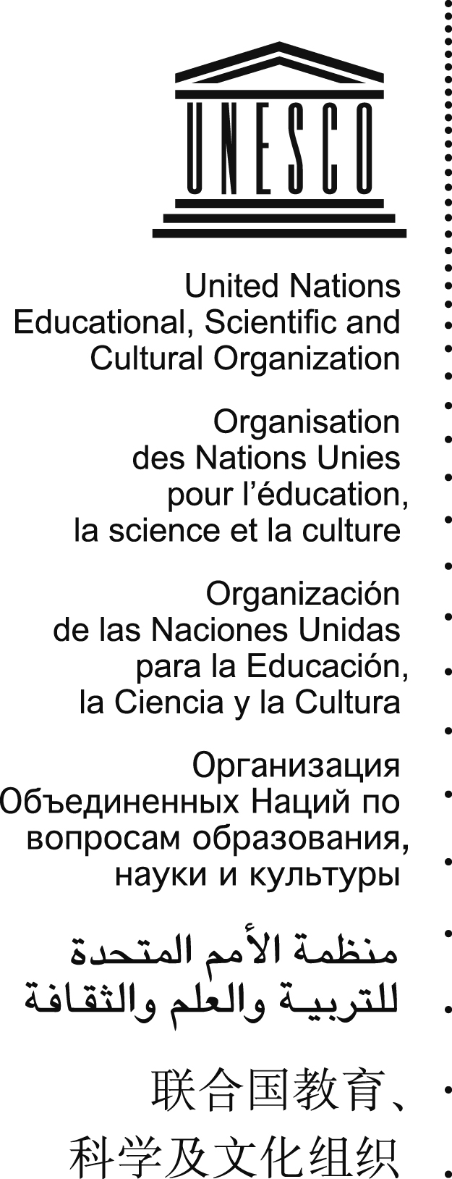
Internal Oversight Service
Evaluation Section
IOS/EVS/PI/129
Original: English
Evaluation of UNESCO’s Standard-setting Work of the Culture Sector
Part I – 2003 Convention for the Safeguarding of
the Intangible Cultural Heritage
EXECUTIVE SUMMARY
October 2013
Barbara Torggler
Ekaterina Sediakina-Rivière
Internal Oversight Service, Evaluation Section
Janet Blake
Consultant
As the only UN agency with a mandate in culture, UNESCO has developed a comprehensive series of standard-setting instruments in this field, including six main culture conventions, many recommendations and a number of declarations. Significant time and resources are spent on standard-setting activities related to these instruments and even though the visibility of some of this work is high, no comprehensive evaluation has ever been conducted of the standard-setting work of UNESCO. It is in this context that UNESCO decided to conduct this evaluation.
Evaluation purpose, scope and methodology
The purpose of the overall evaluation is to generate findings and recommendations regarding the relevance and the effectiveness of the standard-setting work of the culture sector with a focus on its impact on ratification; on legislation, policies, and strategies of Parties to UNESCO’s culture conventions; and on the implementation of the conventions at the national level. A separate report by the IOS Audit Section assesses the adequacy and efficiency of the working methods used in the standard-setting work.
The evaluation aims to help the UNESCO Culture Sector, Senior Management and the Governing bodies of the conventions to strengthen, refocus and better coordinate the organisation’s standard-setting activities. It also wants to contribute to generating a better understanding about how conventions work in practice, i.e. how they affect legislation and policies of Parties and the behaviour of key institutional actors. It thereby intends to serve as a source of information for Member States, who have the primary responsibility for the implementation of the standard-setting instruments at national level.
The overall evaluation examines four of UNESCO’s culture conventions (1970, 1972, 2003 and 2005). The present report constitutes part one of the overall evaluation. It focuses on the 2003 Convention for the Safeguarding of the Intangible Cultural Heritage and looks at the following three levels of standard-setting work and at related activities undertaken both by State Parties and by UNESCO:
- Ratification (or accession / acceptance / approval) of the Convention;
- Integration of the provisions of the Convention into national / regional legislation, policy and strategy; and,
- Implementation of the legislation, policies and strategies at the national level.
The evaluation aims to find out about the results achieved at each of these levels, about the effectiveness of the mechanisms used to support the implementation of the Convention, and about the overall relevance of this standard-setting instrument. It also examines the relevance and effectiveness of the support provided by UNESCO to State Parties to the Convention.
The foundation of the evaluation methodology is constituted by a Theory of Change. This is a summary overview of the key causal assumptions connecting, through a number of intermediate assumptions, the different types of UNESCO support, as well as the actions of State Parties and other stakeholders within the framework of the 2003 Convention, to the final intended objectives. The Theory of Change was reconstructed on the basis of different inputs, such as documents and interviews, as it had not yet been clearly articulated. It provided the basis for a ‘nested’ methodological design, which included purposive sampling and data collection at the different levels of the causal chain from ratification to implementation as basis for acquiring credible data at all three levels. Data collection methods included a desk study, phone/Skype interviews, surveys, and in person interviews in a few selected countries.
Key evaluation findings
State Parties consider the 2003 Convention for the Safeguarding of the Intangible Cultural Heritage to be a highly relevant international legal instrument, both in terms of its consistency with national and local priorities and with the needs of the concerned communities, groups and individuals. This view is also shared by many non-state stakeholders involved in the implementation of the Convention, including NGOs, representatives of intangible cultural heritage (ICH) bearer organisations, and academics. The Convention, and the standard-setting work related to it, is also of relevance to UNESCO’s priorities as described in the current 34 C/4 Medium-Term Strategy and the 36 C/5 Programme and Budget as well as in the draft 37 C/4 and 37 C/5. The specific reasons for considering it relevant and important vary considerably depending on the type of stakeholder consulted and the respective socio-cultural and historical context.
The 2003 Convention has significantly broadened the international discourse around the definition and meaning of cultural heritage. The concept of ICH itself is quite new and its use has largely been credited to the 2003 Convention. As recently as ten years ago the term ICH was almost unknown and was only used by a small group of experts. Intangible Cultural Heritage is today recognized as a valuable and integral part of people’s cultural heritage. The Convention broadened the more traditional view of heritage to include anthropological and sociological points of view. It also introduced a number of important concepts related to ICH, such as the understanding that the community is the real bearer of ICH and that this heritage is defined in terms of the community; the notion that culture is living and evolving as it is transmitted from one generation to another; and the concept of safeguarding as measures aimed at ensuring the viability of ICH.
Overall, due to its standard-setting work related to various conventions, UNESCO is widely recognized as a leader in the field of cultural heritage. Increasingly, the organization is also valued by Member States and other UN agencies for its efforts to demonstrate the links between culture and development. However, although the link between ICH and sustainable development is generally considered to be important, clarifying the nature of this link, identifying its potential both for sustainable development and for the viability of ICH, and identifying the potential risks that development, if not sustainable, holds for ICH, are still very much work in progress.
Many stakeholders acknowledge the gender dimension of ICH. However, an in-depth debate about gender equality and ICH has not yet happened. Given the absence of such a debate and any appropriate guidance, the working mechanisms of the Convention, related documents, forms and assessments, as well as the support provided by the Secretariat have been quite gender blind so far. The same applies to the Periodic Reports. This is a lost opportunity to create awareness about this very important topic and to collect interesting information and good practices that could later be shared with others.
While many State Parties have integrated the Convention’s provisions in cultural policies and laws following ratification, a lot more work needs to be done to establish the required legislative and policy environment, both as it relates to laws and policies in the field of culture, as well as to those in the field of sustainable development that have a bearing on the implementation of the 2003 Convention. This is one of the areas where support is needed and where UNESCO could intervene more explicitly.
In many countries Government institutions lack the financial and human resources to successfully implement the Convention. Understanding the concepts of the Convention also often remains a challenge, both at the government and community levels. This is especially evident when it comes to inventorying, the design and implementation of safeguarding measures, cooperation with other State Parties, preparation of nomination files (both national and multi-national), and community consultation and participation in all of these areas.
Although community participation is at the heart of the 2003 Convention, it has proven to be one of the most challenging aspects in its implementation. Community participation needs to be enhanced in many areas related to the implementation of the Convention, including in inventorying, in the elaboration of safeguarding programmes and projects, and in the preparation of nomination files.
UNESCO has put in place an extensive world-wide capacity building programme with a network of qualified experts. Of all the mechanisms established by the Convention and the Secretariat to support the implementation of the Convention, the capacity building programme is considered by many to be the most important. The programme could usefully be extended to include more support in policy and legislative development; ICH and sustainable development and the required inter-sectoral cooperation; community mobilization and participation; and ICH and gender equality in a context of human rights. More efforts are needed for follow-up and assessment of results achieved by the capacity building activities.
While the Representative List has contributed to increasing the visibility of the Convention and to raising awareness about intangible cultural heritage, its relative importance is overrated. Other mechanisms, such as the List of Intangible Cultural Heritage in Need of Urgent Safeguarding, the Register of Best Safeguarding Practices and the International Assistance are underused. A better balance needs to be found between these mechanisms by (a) clarifying all misperceptions regarding the concepts and intention of the Representative List; (b) promoting and re-positioning the Urgent Safeguarding List; (c) promoting the International Assistance Programme; and (d) rethinking the way best practices are identified and disseminated.
Evaluation of nomination files to the Convention’s mechanisms is undertaken by two separate bodies. This arrangement is questioned by many stakeholders who believe that nominations to the Representative List and to the List of Intangible Cultural Heritage in Need of Urgent Safeguarding should be examined by one body only in order to ensure that the same standards are applied in the evaluation of nomination files. The fact that the members of the Subsidiary Body are representatives of State Parties also raises considerable discontent and concerns about possible conflicts of interest.
The 2003 Convention is closely linked to the 1972 and 2005 Conventions as well as to some of the work of the World Intellectual Property Organization. While this is generally acknowledged by stakeholders, possibilities for strengthening policy and implementation connections, exchanging experiences and enhancing cooperation between the various culture conventions, and between UNESCO and WIPO have not been fully exploited.
NGOs are acknowledged to play an important role in the implementation of the Convention at the national level. Their contribution is primarily focused on the implementation of safe-guarding measures. Other important roles, such as contributing to cultural policy making or mediating and building bridges between various actors, such as between communities and Government, are less recognized. At the international level, entry points for NGOs, including organizations representing ICH bearers, to contribute to decision making are limited. Many accredited NGOs feel that their accreditation status is not taken seriously by the IGC as the NGO forum Statement and individual contributions of NGOs and other observers are often not sufficiently considered during the debates and therefore do not have much effect on decisions taken by the IGC. One of the reasons for why NGOs’ views are not taken into consideration by the IGC seems to have to do with the accreditation criteria of NGOs, which are not stringent enough. This has led to the rapid approval of many organisations that are not playing a very active role in the implementation of the Convention.
Overall, the Convention lacks a Theory of Change and an overall results framework with objectives, time-frames, indicators and benchmarks, which makes it difficult to capture and demonstrate results. Periodic reports provide a valuable source of information on the implementation of the Convention. However, for the purpose of monitoring the implementation of the Convention globally, the Reports alone currently do not provide all the required information. The reporting format should be revised and the Reports complemented by other sources, so that a more complete data set on results achieved and lessons earned can be established.
The work of the UNESCO 2003 Convention Secretariat is considered to be of high quality. Overall its services are much appreciated by State Parties, who consider the Secretariat to be professional, efficient and responsive. The Secretariat, however, lacks resources, which has put constraints on the number of nominations and proposals processed and on other activities.
The evaluation generated a large number of recommendations directed to the Intergovernmental Committee for the Safeguarding of the Intangible Cultural Heritage and to the 2003 Convention Secretariat. They are included in the respective chapters of the report and a full list is available in chapter 8 of this report and reproduced below.
Recommendation 1. Revise all relevant documents and forms (including the Operational Guidelines, the Periodic Reporting Formats, and nomination files) to include gender-specific guidance and questions.
Recommendation 2. Promote increased NGO and community involvement in the development of policy, legislation, safeguarding plans and sustainable development plans.
Recommendation 3. Enhance cooperation with sustainable development experts for integrating ICH into non-cultural legislation and policy, and for other work related to ICH and sustainable development.
Recommendation 4. Support State Parties with the development of legislation and policy as part of the ongoing 2003 Convention capacity building programme and design appropriate capacity building formats to do so.
Recommendation 5. Cooperate with sustainable development experts when supporting State Parties with the integration of ICH into non-cultural legislation and policy, and with other work related to ICH and sustainable development.
Recommendation 6. Establish, with the full involvement of UNESCO field office and in cooperation with National Commissions, a follow-up mechanism for capacity building activities to gather data about their effectiveness.
Recommendation 7. Review (and adapt if necessary) the content and format of the capacity building strategy to ensure that it responds to the major implementation challenges at the national level.
Recommendation 8. Promote the USL by re-positioning it as an expression of State Parties’ commitment to safeguarding and to the implementation of the Convention, and especially recognise those State Parties that submit nominations to the USL.
Recommendation 9. Clarify to State Parties and other stakeholders all misconceptions regarding the purpose and use of the Representative List.
Recommendation 10. Ensure that inscription of elements to the Representative List reflect more closely the criteria and procedures specified in Chapter I.2 of the Convention’s Operational Guidelines.
Recommendation 11. Suspend the Subsidiary Body, so that all nominations are evaluated by one common and independent body.
Recommendation 12. Reconsider and complement the Register of Best Safeguarding Practices by developing alternate, lighter ways of sharing safeguarding experiences such as dedicated websites, e-newsletters, online forums, etc. (This recommendation is linked to Recommendation 19.)
Recommendation 13. Give priority to International Assistance requests within the ceiling of files to the Convention’s mechanisms.
Recommendation 14. Promote International Assistance as a capacity building mechanism for State Parties.
Recommendation 15. Strengthen UNESCO’s cooperation with WIPO over traditional knowledge and culture to ensure an ongoing exchange and learning between the two organisations and their Member States, especially in the context of WIPO’s current discussions about a new international standard-setting instrument for the protection of the intellectual property rights of communities.
Recommendation 16. Create opportunities for joint thinking, exchange of experiences, cooperation and synergies between UNESCO’s culture conventions of 1972, 2003 and 2005 and establish appropriate mechanisms for this.
Recommendation 17. Encourage representatives of accredited NGOs to participate in IGC debates prior to voting on agenda items and include the outcomes of the NGO forums (such as the NGO Statements) in the Committee agendas.
Recommendation 18. Revise the accreditation process and criteria for NGOs to ensure that all accredited NGOs have the required experience and capacity to provide advisory services to the Committee.
Recommendation 19. Encourage a debate on the role of the private sector and of private/public partnerships in safeguarding ICH at all levels (national, regional and international) in order to better define its potential for cooperation and involvement.
Recommendation 20. Strengthen informal sharing of interesting and innovative examples on working on the Convention, including about ICH safeguarding, development of policy and legislation, ICH and sustainable development, innovative partnerships and others.
Recommendation 21. Revise the periodic reporting form to include specific questions on policy, legislation and gender, and to ensure that the reports focus on results rather than on activities.
Recommendation 22. Develop an overall results framework for the Convention, linked to a Convention Theory of Change and including clear objectives, time-frames, indicators and benchmarks.
Recommendation 23. Complement the data gathered on the implementation of the Convention through Periodic Reports submitted by State Parties with information provided by NGOs.
Recommendation 24. Strengthen monitoring and evaluation of the implementation of the Convention at the national level.

ANNEX II
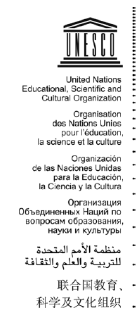
Internal Oversight Service
Audit Section
IOS/AUD/2013/06
Original: English
Audit of the Working Methods of Cultural Conventions
September 2013
Auditors:
Hir Purkait
Slavka Douet
Nicola Tabacchi

EXECUTIVE Summary
Key Results
lOS conducted an audit of the working methods of the six conventions in the field of culture to assess the adequacy and efficiency of the working methods of UNESCO’s standard-setting work in the Culture Sector. The audit found that the current situation is unsustainable as support from the regular programme budget decreases and the workload of the convention secretariats increases. There is thus a need to review the amount of secretariat work that can be executed and cost-saving measures should be considered. Potential measures include reducing the frequency, duration and agenda of the meetings of governing bodies, synchronizing the meetings of the general assemblies, temporarily suspending fresh nominations, and using more sponsors for meeting expenses, including for translation and interpretation. The audit also found that there is an opportunity for a common platform across the culture conventions for support services given the synergies and nature of functions. Finally, alternative funding structures, such as those employed by other United Nations multilateral environment agencies, should be considered.

Background
- Promoting Standard-setting instruments is one of the five established functions of UNESCO. In the field of culture, UNESCO promotes cultural Conventions and Protocols as detailed below.
2005 Convention on Protection and Promotion of the Diversity of Cultural Expressions
2003 Convention on Safeguarding of the Intangible Cultural Heritage
2001 Convention on Protection of the Underwater Cultural Heritage
1972 Convention Protection of the World Cultural and Natural Heritage
1970 Convention on Fighting Against the Illicit Trafficking of Cultural Property
1954 Convention on Protection of Cultural Property in the Event of Armed Conflict (1st Protocol and 2nd Protocol)
- Implementation and support to these conventions forms a significant part of the UNESCO Culture Sector activities. In recent years, the total budgets of the six active conventions and protocols comprised about 80 per cent of the overall Culture Sector budget.
- The importance of these conventions can be seen from the increasing ratification of (State) Parties as shown in the graph below.
Graph 1
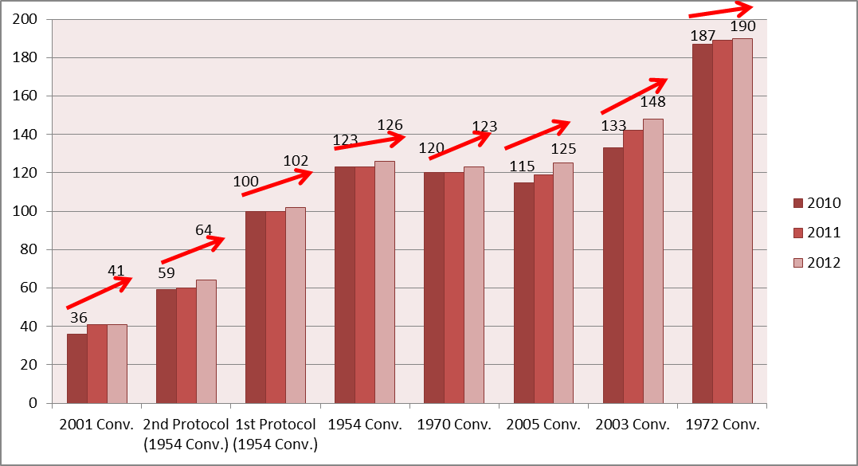

- There are generally three funding modalities to support the activities under these conventions. 1) UNESCO Regular Programme support by way of activity funding and staff resources, 2) Dedicated funds for convention based on either assessed or voluntary contributions from the Member States, and 3) Other extra-budgetary funding. The total budgets for the biennium 2012-13, by convention are shown in the graph below.
Graph 2
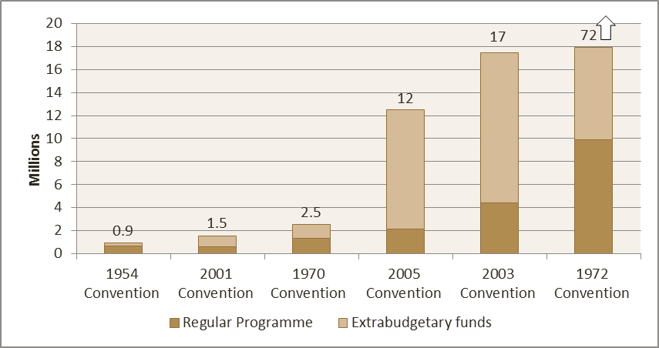

Source: FABS data July 2013. 33,9 Million USD is managed by the World Heritage Centre and 38.8 Million USD is delegated to UNESCO field offices.
- Working methods of the governing bodies and broad functions of the secretariats are guided by the convention text as well as operational directives and rules of procedures adopted by the Governing Bodies of each convention.
- Governance arrangements of these conventions are defined in the convention texts, and specific duties of each constituency are in the Operational Guidelines/Directives. The Conference/Assembly of State Parties is the highest decision making body and meets periodically, generally once in two years.
- Four of the conventions are supported by intergovernmental committees, which meet annually or more frequently and are empowered to take decisions as per the convention texts and operational guidelines of the conventions. The sizes of these committees vary from 18 to 24 members, elected from the six UNESCO regional electoral groups for the election of Members of the Executive Board (except in case of the Second Protocol of the 1954 Convention). In addition, some conventions have subsidiary bodies/consultative bodies to support the work of the committee.
- As mentioned in the texts of these conventions, UNESCO provides secretariats for the conventions. The roles of the secretariats, as defined in the convention text and in the operational directives are essentially twofold, i.e. a) to help organize the meetings of the Governing Bodies (i.e. Conference/Assembly of State Parties and Intergovernmental Committees) and b) to implement their decisions and recommendations as well as to perform any other function entrusted to them.
- A Cultural Convention Liaison Group (CCLG) comprising of the heads of the convention secretariat has been established to increase coordination among conventions. The Group first met in January 2012.

Scope, objective and methodology
- IOS conducted an audit of the working methods of the six conventions in the field of culture, in order to assess the adequacy and efficiency of the working methods of UNESCO’s standard-setting work. The audit was performed in accordance with the International Standards for the Professional Practice of Internal Auditing.
- The scope of the review included working methods of the convention secretariats, the funding arrangements and the meetings of the governing bodies. For the purpose of this audit, all six active conventions were reviewed.
- The methodology of the audit included data and information gathering through a review of convention texts, operational guidelines, rules of procedures as well as prior studies and reviews and interviews with the staff of the convention secretariats. In addition, the audit reviewed funding and governance structure in a number of similar UN conventions hosted outside UNESCO for benchmarking purposes.
Achievements:
- Member States assign high priorities to the convention related activities. During the prioritization exercise by the Executive Board (the 5th Special Session), the expected results relating to all six conventions received Medium- High (B-A) priority (meaning a budget priority between 40-100 per cent) with special mention for resource support to the 1970 Convention.
- In recent years, efforts have been made to increase coordination among various convention secretariats. A Cultural Convention Liaison Group (CCLG) comprising the heads of the convention secretariats has been established. This group has high potential to foster coordination and efficiencies among the convention secretariats. To achieve this potential, the group would need clear roles and accountabilities.
Challenges and Opportunities:
- Increasing workload with decreasing funding is unsustainable. Over the years, work of the convention secretariats has increased due to an increase in the number of: a) (State) Parties to the conventions; b) statutory meetings and their bodies; c) decisions and recommendations to be implemented by the secretariat; d) nominations to the conventions’ mechanisms; e) international or any other category of assistance requests, f) design and implementation fundraising campaigns and communication strategies and g) processing and analysis of periodic reports. In addition, there are increasing demands from Parties for capacity building and technical assistance in the implementation of the Conventions at country level as well as for the production, management and distribution of knowledge in line with UNESCO’s overall objectives to act as a clearing house and laboratory of ideas. These activities have been determined as priority by the governing bodies, in particular for the development of policies and action plans, gathering qualitative and quantitative evidence, content development distributed through knowledge sharing platforms, thematic debates on key articles of the Conventions. However, the total funding for the activities and staff resources are on decline. The decline is likely to be aggravated in the coming biennium due to overall budgetary cuts in UNESCO. There is a need to prioritise the activities of the convention secretariats and explore other funding models.
- Governing Bodies meetings should be more efficient and cost effective by reducing the frequency of meetings to align with the forthcoming quadrennial programming cycle of UNESCO, by limiting the meeting durations, by synchronizing the meetings of General Assemblies of the conventions, possibly just after the UNESCO General Conference meetings and by harmonising the translation and interpretation requirements across the convention meetings. The Executive Board in its 191st session recommended that the General Conference, at its 37th session, request the governing bodies of all intergovernmental and other bodies to address the efficiency and effectiveness of their meetings and formulate governance reform and cost-saving measures as appropriate.
- There is a need to review the cost structure of the advisory services (E.g. process requests for nomination and international assistance, impart trainings and undertake monitoring activities) provided by these statutory bodies to find more cost effective ways. Conventions follow different working methods for processing of nominations and International Assistance requests. Advisory services obtained from the three statutory bodies constitute a large part of the 1972 Convention budget.
- Support services such as IT and Web design & maintenance, communication and meeting logistics are fragmented across the convention secretariats and a common platform for such services would be more efficient.
- A coordinated fund raising strategy with common resource mobilization team would be more effective for raising extrabudgetary resources and will also provide an opportunity for common branding of UNESCO cultural conventions.

Table of recommendations
Recommendation 1: We recommend that the convention secretariats formulate proposals to the Governing Bodies of UNESCO and/or of the Convention(s) to:
  - Supplement the current funding structure with General Trust funds formed out of contributions from the Contracting (State) Parties on compulsory or voluntary basis to cover the ordinary expenditures of the secretariats, including staffing, administrative costs, preparation and translation of documents,
  - prioritize the current work load of the convention secretariats to align it with available resources,
  - reduce the frequency, when feasible, duration and agenda of the meetings of State Parties and that of the Intergovernmental Committees and synchronize the meetings of the State Parties to the conventions, when efficiencies can be achieved,
  - harmonize the translation and interpretation requirements across the convention meetings and seek extrabudgetary funding for additional languages, and
  - modify the financial rules and regulations if necessary to allow application of cost recovery policy.
Recommendation 2: We recommend that the convention secretariats, where applicable, explore more efficient ways of the obtaining advisory services and consider potential chargeback mechanisms to the nominating State Parties and/or earmarked fund and formulate proposals to the respective Governing Bodies for possible economies and financial sustainability in the advisory service fees.
Recommendation 3: We recommend that the CLT Sector should expand its common logistics unit to include additional services that add value and provide cost-effective solutions to support the work of all convention secretariats. The platform can function under the guidance of the Cultural Convention Liaison Group.
Recommendation 4: We recommend that the CLT Sector formulate, in consultation with BSP/CFS, a coordinated fund raising strategy for all conventions secretariats and form a common resource mobilization team.

results of the audit
Issue 1: Increasing workload with decreasing funding is unsustainable.
- Effective implementation of the conventions form a very large part of UNESCO’s Culture Sector activity. The roles of the secretariats, as defined in the convention text are twofold, i.e. a) to help organize the meetings of the Governing Bodies (i.e. Committee/Assembly of State Parties and Intergovernmental Committees) and b) to implement decisions of the Governing Bodies.
- Based on the abovementioned role, the secretariat generally undertakes the following activities;
    - Organizing statutory and other meetings relating to the conventions and implementation of their decisions and recommendations
    - Providing expert advice on different aspects related to the implementation of the Conventions and performing the function of a clearing house and laboratory of ideas
    - Providing support to the Intergovernmental bodies in processing and evaluating of the State Parties (SPs) requests (e. g. listing) and providing feedback to SPs, for inscription based conventions
    - Capacity building in SPs, either to support the convention through training and other activities or providing assistance in formulating proposals for inscriptions
    - Processing and analysing periodical reports
    - Design and implementation of fundraising campaigns and communication strategies to raise visibility of the conventions, how to implement them and build platforms for participatory policy making processes through partnerships with public authorities, civil society representations and private sector (e.g. SME’s). Management of the relevant intergovernmental funds and establishment of contracts for the granting of international and other categories of assistance, including monitoring implementation and evaluation of projects financed by these funds.
Over the years, workload of the convention secretariats has gone up due to an increase in number of: a) States Parties to the convention; b) statutory meetings and their bodies; c) decisions and recommendations to be implemented by the Secretariat; d) nominations; and e) periodic reports.
- Increase in the number of State Parties ratifying the convention is shown in the Graph 1 of this report. Trend in number of inscriptions for the two main inscription based conventions, i.e. Protection of the World Cultural and Natural Heritage (1972 Convention) and Safeguarding of the Intangible Cultural Heritage (2003 Convention), are shown below in Graph 3 and 4. Increase in number of inscriptions also lead to increase in processing of requests and reporting requirements.
Graph 3
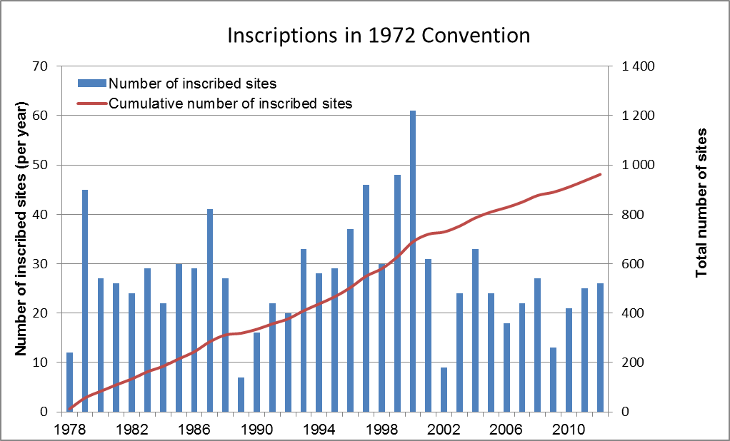
Graph 4
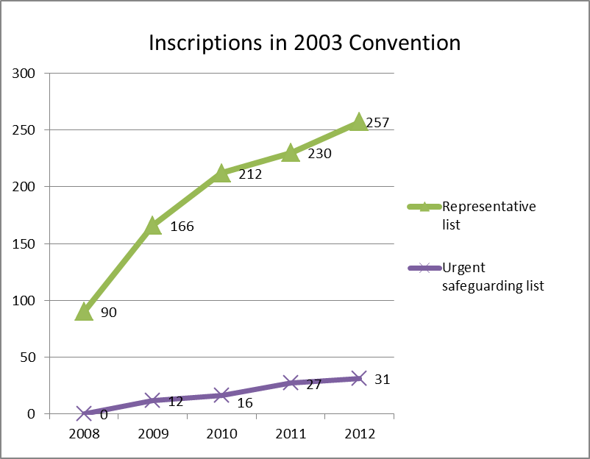
- While the work of the convention secretariats has increased over the years, the financial resources of the secretariats have not been in tandem with the workload. Three funding modalities support the conventions’ activities: (1) UNESCO Regular Programme support by way of activity funding and staff resources; (2) dedicated funds for a convention based on either assessed or voluntary contributions from Member States; and (3) other extrabudgetary funding. The activity support includes funding of some costs related to governing body and other subsidiary body meetings of these conventions, e.g. costs relating to translation, interpretation and some participant travel.
- The trends of total budget of the conventions over the last three biennia are given below in graph 5.
Graph 5
(source: 34C/5, 35C/5 and 36C/5)
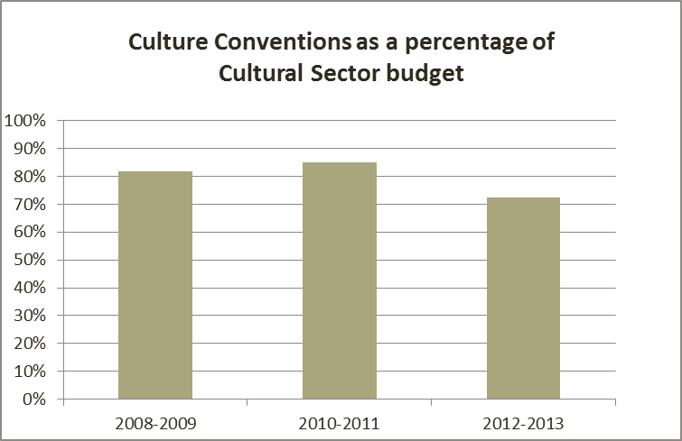
- With the pressure on UNESCO regular programme budget for the next biennium, there is likely to be a significant reduction in the regular programme budgetary support to the convention budgets. It is relevant to mention here that during the prioritization exercise by the Executive Board (the fifth special session), the expected results relating to all six conventions received B-A priority (meaning a budget priority between 40-100 per cent) with special mention for resource support to the 1970 Convention.
- Convention secretariats have been looking for extrabudgetary funds as well as other modalities like sponsorship of meetings of intergovernmental bodies leading to co-sharing of some of the meeting costs. However, the likely decrease in regular programme funding makes it difficult if not impossible to sustain the current workload.
- Given the likely decline in financial resources for the next biennium, there is a need to align the secretariat workload with the financial resources. Some of the possible measures to prioritise/reduce the workload of the secretariat are discussed in detail in a later part of this report. As pointed out earlier, the role of the convention secretariats relate to the arranging for the meetings of the Governing Bodies and implementing their decisions. Therefore, implementations of all decisions of the Governing Bodies become mandatory responsibility of the secretariats. It is pertinent to note that while the financial resources by way of regular programme budget support for activities and staff levels are decided by the UNESCO Executive Board and General Conference, the activities of the secretariats are guided by the decisions taken by Governing Bodies of each convention. This creates a misalignment between the activities to be undertaken by the secretariats and available resources.
- It is relevant to mention that a Joint Inspection Unit review of 45 conventions hosted by 11 different United Nations Organizations revealed that, general trust funds, formed through contributions from the Contracting (State) Parties on compulsory or voluntary basis, are used to meet the expenses of the conventions, covering the ordinary expenditures of the secretariats, including staffing, administrative costs, preparation and translation of documents. Special trust funds meet the extra-budgetary expenses for technical assistance and the participation of developing countries and countries with economies in transition in convention meetings. Similar funding structure can be explored for convention secretariats hosted by UNESCO to avoid governance overlap and ensure independence from UNESCO’s regular programme budget.
Recommendation 1 (a):
We recommend that the Convention Secretariats formulate proposals to the Governing Bodies of UNESCO and those of the Conventions to supplement the current funding structure with General Trust funds formed out of contributions from the Contracting (State) Parties on compulsory or voluntary basis to cover the ordinary expenditures of the secretariats, including staffing, administrative costs, preparation and translation of documents. | High risk
CLT action plan:
The issue requires further discussions with BFM and LA before submitting proposals to the respective Governing Bodies, which could be based on the already approved sub fund for staffing for the 2003 Convention. Further, given the different meeting schedules of the Governing Bodies of the conventions, the implementation of the recommendation is foreseen by December 2015.

Recommendation 1 (b):
We recommend that the Convention Secretariats formulate proposals to the Governing Bodies of UNESCO and those of the Conventions to prioritise the current work load of the convention secretariats to align it with available resources. | High risk
CLT action plan:
The governing bodies have given very clear priorities regarding the work to be done. The longstanding issue of the mismatch between the workload and human resources available to deliver on these priorities has become ever more critical in view of the reduced anticipated cash flow 2014-2015. The Secretariats of the Conventions will present proposals to better align workload with available resources. However, the different meeting schedules of the Governing Bodies of the conventions means that the implementation of the recommendation is foreseen by December 2015.

Issue 2: Meetings of the Governing Bodies need to be made more efficient and cost effective
- Organising meetings of the Governing Bodies are one of the essential roles of the convention’s secretariats as defined in the texts of the conventions. Organizing the State Party/intergovernmental body meetings take up considerable amount of secretariat staff time and financial resources. Some costs related to these meetings are charged to the dedicated fund or other extrabudgetary resources related to the conventions; however costs relating to translation, interpretation and some participant travel are borne by the UNESCO regular programme.
- Comparative information on the Governing Body meeting frequency, duration and languages to be used, as prescribed in the conventions’ texts is presented below.
Table 1
 | 1972 | 1954 Hague | 1999 Second Protocol | 1970 | 2001 | 2003 | 2005
State Parties meetings
Name | General Assembly | High Contracting Parties | Parties to the Second Protocol | Meetings of States Parties | Meeting of States Parties | General Assembly | Conference of Parties
Frequency of meetings | Every two years | Every two years | Every two years since 2005 | 2003, 2012  2013 | Every two years | Every two years  (One extraordinary session) | Every two years
Duration | 2-3 days | 3 hours - morning | Afternoon and 1 day | 2 days | 3 days | 5 days | 3-4 days
Place | Paris since 1987 | Paris | Paris | Paris | Paris | Paris | Paris
Working languages | All Six languages of UNESCO | All six languages of UNESCO | All six languages of UNESCO | All Six languages of UNESCO | All Six languages of UNESCO | All Six languages of UNESCO | All Six languages of UNESCO
Intergovernmental Committee meetings
Frequency | Every year (10 extraordinary sessions ) | N/A | Every year from 2006, one extraordinary in 2009 | First meeting in 2013;  Every year | N/A | Every year  (4 extraordinary sessions) | Every year
Duration | About 10-12 days in the last 4 meetings; | N/A | 2 days | 2 days | N/A | 5 days | 4-5 days
Place | Hosted by Member States | N/A | Paris | Paris | N/A | Generally outside Paris, last session in Paris | Paris
Working languages | ENG/FRA | N/A | All Six languages of UNESCO; (currently interpretation in English, French and Spanish and working documents in English and French are provided through an agreement). | ENG/FRA | N/A | ENG/FRA | ENG/FRA

Frequency of meetings
- As seen from the table 1 above, in general the (State) Parties to the conventions meet once in two years, whereas the Intergovernmental Committees meet once every year. The move in UNESCO from a biennial to a quadrennial programming cycle creates opportunities for changes in the frequency of governance meetings. A logical rule of thumb might be to halve the number of governance meetings, i.e. to hold (State) Party meetings once in every four years and Intergovernmental Committee meetings once every two years.

Duration of meetings
- The meetings of (State) Parties were held for one to five days whereas the Intergovernmental Committee meetings lasted from two to twelve days. Although the Governing Body meetings have diverse agendas, there is a scope for limiting the meetings to not more than one week.

Meeting schedules
- All meetings of (State) Parties are held at UNESCO headquarters where some of the Intergovernmental Committee meetings are cohosted by (State) Parties. 87 (State) Parties are common to four conventions. (State) Parties are at times represented by the same person to different convention meetings. Therefore, there is an opportunity to avoid multiple travels and exploit synergies across the conventions by synchronising the meetings of the State Parties to the conventions, possibly during or just after the UNESCO General Conference meetings.

Translation and interpretation requirements
- At present, six language interpretation and translation is provided in all General Assembly/Conference of Party meetings whereas translation and interpretations in English and French are provided for Intergovernmental Committee meetings, with the exception of the 1999 Second Protocol and 2001 Convention where three language interpretations are provided in committee/advisory body meetings. Translation and interpretation requirements across the convention meetings can be harmonized in such a way that meetings of (State) Parties are held in all six working languages, whereas the Intergovernmental Committee meetings are held in English and French. It is relevant to mention that the cost of two way interpretation in French and English is $2,670 per day, whereas the cost of six-language interpretation comes at $12,460 per day.
Recommendation 1 (c):
We recommend that the Convention Secretariats formulate proposals to the Governing Bodies of the Conventions to (i) reduce the frequency, duration and agenda of the meetings of State Parties and that of the Intergovernmental Committees and (ii) synchronize the meetings of the State Parties to the conventions when efficiencies can be achieved. | Medium risk
CLT action plan:
CLT accepts the spirit of the recommendation, but notes that changing frequency of the meetings would require amendment of the Conventions which CLT will not propose at this time. Some of the meetings of the governing bodies currently take place back to back, with particular bottlenecks in June and December. It has been expressed that this time schedule is unsustainable and not efficient as Parties do not have sufficient time between meetings to fully prepare for the debates and, in many cases, are not able to attend, given the intensity of the schedule. The Secretariat will submit proposals for revising the scheduling of meetings, as well as the duration and agenda. Given the different meeting schedules of the Governing Bodies of the Conventions, the implementation of the recommendation is foreseen by December 2015.
IOS comment: Notwithstanding these challenges noted by CLT, we encourage CLT’s continued efforts to examine and reduce meeting costs as proposed in the recommendation.

Recommendation 1 (d):
We recommend that the Convention Secretariats formulate proposals to the Governing Bodies of the conventions to harmonise the translation and interpretation requirements across the conventions meetings and seek extrabudgetary funding for additional languages. | Low risk
CLT action plan:
Given the different meeting schedules of the Governing Bodies of the conventions, the implementation of the recommendation is foreseen by December 2015.
Recommendation 1 (e):
We recommend that the Convention Secretariats formulate proposals to their respective Governing Bodies to modify the financial rules and regulations if necessary to allow consistent application of cost recovery policy. | Medium risk
CLT action plan:
The Sector will present proposals in this regard to the respective Governing Bodies. Given the different meeting schedules of the Governing Bodies of the conventions, the implementation of the recommendation is foreseen by December 2015.

Issue 3: Working methods on processing of Nomination and International Assistance requests differs across conventions
- Comparative information on processing of nominations and international assistance requests across the conventions is presented in the table below.
Table 2
 | 1972  Convention | 1954  Convention | 1970  Convention | 2001 Convention | 2003  Convention | 2005  Convention
Lists | 1. World Heritage List  2. List of World Heritage in Danger | 1. List of Cultural Property under Enhanced Protection (Second protocol of 1999)  2. International Register of Cultural Property under Special Protection | None | None | 1. Representative List of the ICH of Humanity  2. List of ICH in Need of Urgent Safeguarding  3. Register of Best Safeguarding Practices | None
Inscription cycles | 18 months  Initial submission in February and Com decision in June of the following year | No specific cycle for inscription in the Register under the 1954 Convention but requests for inscription in the Second Protocol List are to be submitted to the Secretariat by 1 March every year. This requirement does not concern requests for provisional enhanced protection which may be submitted at any time. | N/A | N/A | 20 months  Initial submission by 31 March. Examination by Committee in December of the following year | N/A
International and other categories of assistance and deadline for requests | Submission latest by 31 October, except for Emergency Assistance that can be submitted at any time in the year. | 1./preparatory, emergency, recovery assistance  2./ financial assistance  Requests for international  Request for international assistance provided by the Committee must be submitted to the Secretariat at least six months before the ordinary meeting of the Committee. Requests for emergency assistance may be submitted any time. |  |  | Same as inscription cycle for AI more than 25,000 and preparatory assistance  At any time for less than 25,000 | Annual financial assistance requests for projects made to the International Fund for Cultural Diversity  Requests for participatory assistance from Parties belonging to LDC’s members of the IGC
Name of advisory body | IUCN, ICOMOC, ICCROM | None | None | Scientific and technical advisory body | Subsidiary Body of the Committee for RL, Consultative Body (for USL, BSP and AI more than 25,000), Bureau for AI less than 25,000 | Panel of experts
- The two main inscription based conventions, i.e. Protection of the World Cultural and Natural Heritage (1972 Convention) and Safeguarding of the Intangible Cultural Heritage (2003 Convention) have similar inscription cycles but follow different approaches in processing nomination requests.
- The 1972 Convention text itself identifies three advisory bodies (i.e. IUCN, ICOMOS and ICCROM) and defines their roles in assessment of the nomination requests. The advisory bodies provide evaluation on the requests for nominations and international assistance and have other advisory, training and reactive monitoring roles. The contracts for the advisory bodies represent more than 75 per cent of the approved budget of the World Heritage Fund. The level of activities and their respective approved budgets for the biennium 2012-13 are given in the table below.
Table 3
(Budgets in US dollars)
Advisory bodies | Advisory services  Activities Budget |  | Reactive Monitoring Missions  Activities Budget |  | Training Activities  Activities Budget
ICOMOS | 1. Evaluation of 31 nominations of cultural or mixed natural/ cultural properties  2. Comment on 25 International Assistance requests, review of 5 Statements of Outstanding Universal Value of properties, etc.  3. Meetings Attendance (World Heritage Committee, General Assembly, WHC/AB meetings, etc.) | 1,442,856.57 | 1. Undertake 24 reactive monitoring missions, peer reviews, desk reviews, etc.  2. Drafting of 53 reports on the state of conservation, review of 55 reports on the SOC  3. Meetings Attendance (SOC meetings, etc.) | 569,664.97 | N/A | N/A
IUCN | 1. Evaluation of nominations of natural or mixed natural/cultural properties  2. Comment on International Assistance requests, etc.  3. Meetings Attendance (World Heritage Committee, General Assembly, WHC/AB meetings, etc.) | 1,156,506 | 1. Undertake 24 reactive monitoring missions  2. Produce State of Conservation reports, etc. | 603,138 |  | NIL
ICCROM | 1.Review and advise on International Assistance requests and other professional services  2. Meetings Attendance (World Heritage Committee, General Assembly, WHC/AB meetings, etc.) | 186,734 | 1. Undertake 4 reactive monitoring missions | 22,507 | 1. Implementation, coordination and monitoring of the World Heritage Capacity Building Strategy  2. Pilot activity  3. Workshop  4. Committee orientation sessions | 108,424
- Under the 2003 Convention, a consultative body of six individual experts and six NGOs examine proposals for the nominations to the Urgent Safeguarding list and Register for Best Safeguarding practices as well as requests for international assistance greater than $25,000. The nominations to the representative list are examined by a different body, called Subsidiary Body, comprised of representatives of the State Parties. During 2012-13, the consultative body examined 8 nominations for Urgent Safeguard list, 2 nominations for the Register of Best Safeguarding Practices and 10 cases of international assistance. The total expenditure incurred during the biennium (at the time of the audit in July 2013) was $109,176. The 2003 Convention Secretariat pointed out that relatively lower expenditure is due to more intensive staff inputs that are not accounted.
- While the role of the advisory bodies in the 1972 Convention is very extensive and cannot be exactly compared with the work done by the Consultative Body under the 2003 Convention, it appears that the unit cost of assessments by the Advisory Bodies in 1972 Convention was significantly higher. In addition, studies have shown that the Committees often disregard the advice of the advisory bodies when deciding on nominations. The External Auditor of UNESCO in its report on the audit of the Global Strategy and the PACT initiative also commented on the increasing politicization of the Committee’s decisions.
Recommendation 2:
We recommend that the Convention Secretariats, where applicable, explore more efficient ways of the obtaining advisory services and consider potential chargeback mechanisms to the nominating State Parties and/or earmarked fund and formulate proposals to the respective Governing Bodies for possible economies and financial sustainability in the advisory service fees. | Medium risk
CLT action plan:
The issue requires further discussions with BFM. Further, given the different meeting schedules of the Governing Bodies of the conventions, the implementation of the recommendation is foreseen by December 2015.

Issue 4: A common service platform across the Secretariats would bring efficiency gains
- Each convention has a separate secretariat, which forms part of the Culture Sector. Convention secretariats vary in sizes and are organised differently. For instance, the 1972 Convention Secretariat is in the World Heritage Centre (WHC) and has the largest secretariat staff. WHC is organized largely on a regional basis. The 2003 Convention is organized on a functional basis. Other convention secretariats have a flat structure given the smaller staff strengths. The organization chart of these convention secretariats are given below.

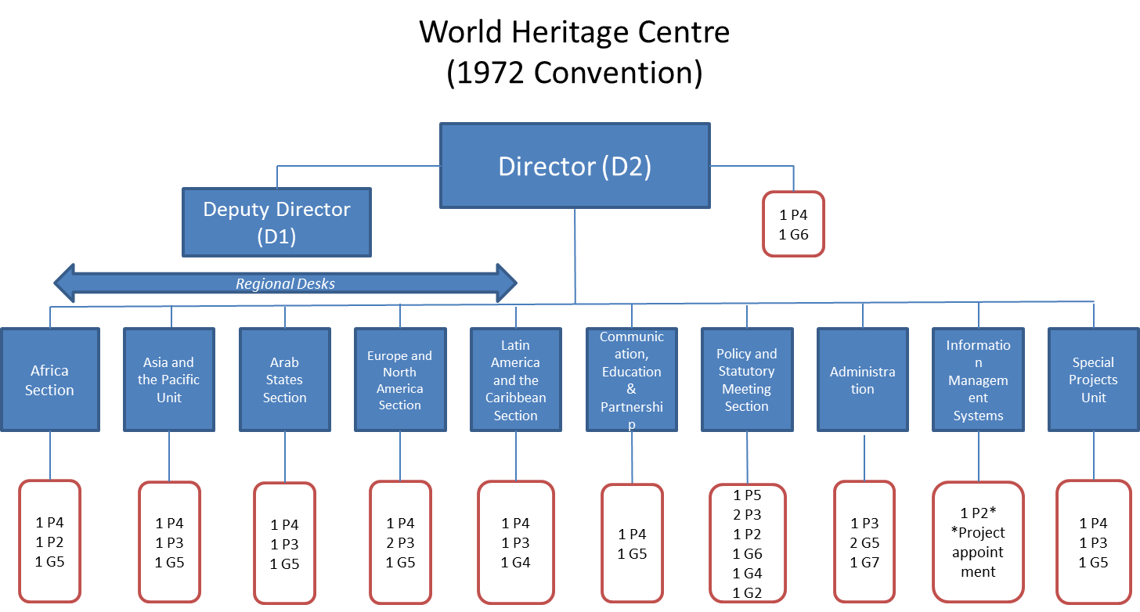
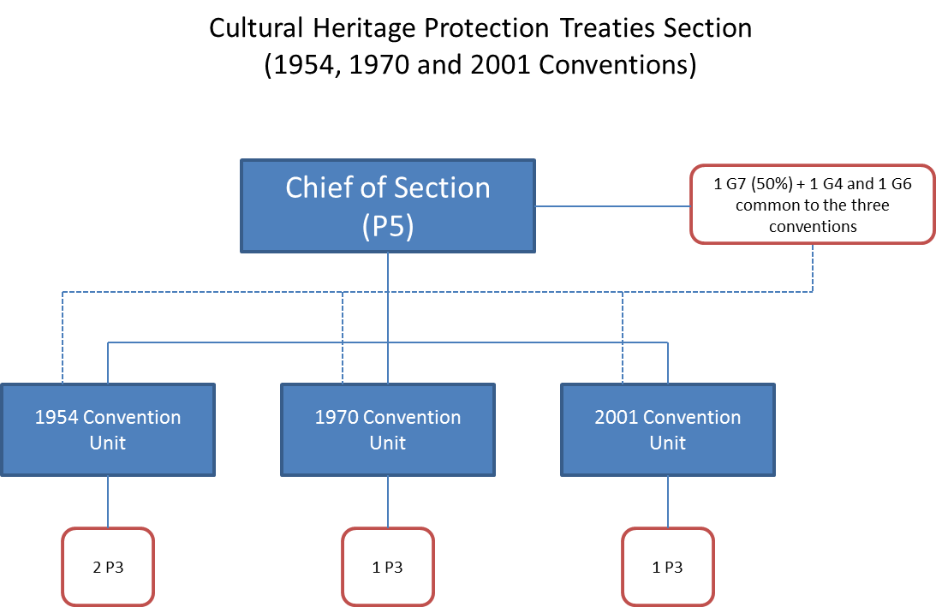
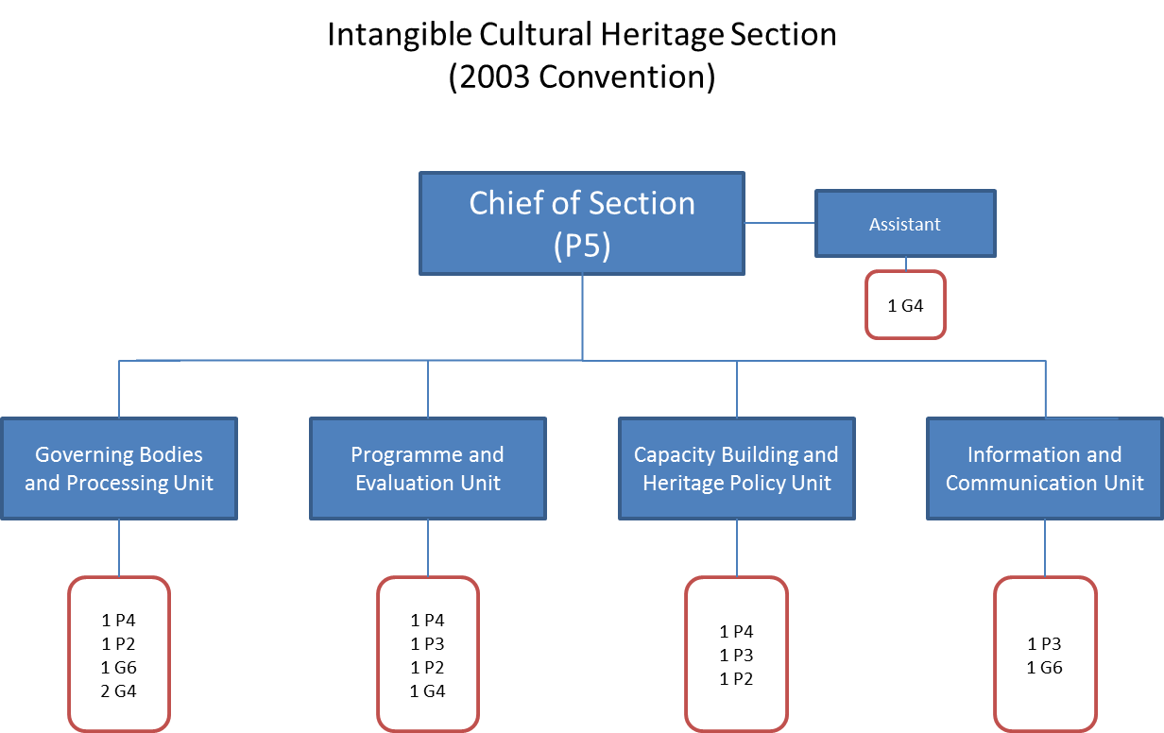

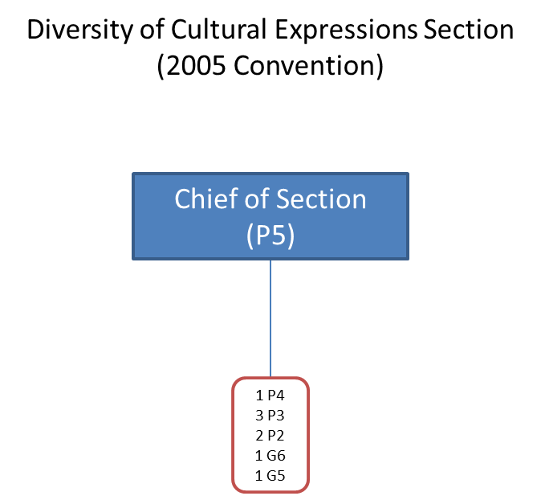
- As seen from the organization charts, support services such as IT and Web design & maintenance, communication and meeting logistics are thinly spread across convention secretariats. This results in overlapping of resources and inadequate support service for some of the smaller conventions, e.g. 1970, 1954 and 2001 Conventions. Some efforts have been done with regard to sharing of common resources, e.g. sharing of resources for logistic services. Common support platform servicing all convention secretariats can improve efficiency through increased synergies and economies of scale to deliver better services across the conventions. CLT Sector pointed out that some of the positions relating to common services are financed from extrabudgetary resources thus making it difficult for sharing them across the conventions. This issue can be overcome with an effective chargeback scheme and cost recovery arrangement.
Recommendation 3:
We recommend that CLT Sector expand its common logistics unit to include additional services that add value and provide cost-effective solutions to support the work of all convention secretariats. The platform can function under the guidance of the Cultural Convention Liaison Group (CCLG). | Medium risk
CLT action plan:
A common logistics unit has been in place for some time to coordinate the physical organisation of the meetings of governing bodies. The Sector has proposed to establish a new structure, called the conventions common services unit, effective 1 January 2014, which would undertake such services as well as a range of outreach services such as publications, website, exhibitions, patronage, and coordinating partnerships, including with existing and future category 2 centres, UNESCO Chairs and the private sector.
Issue 5: Need for a coordinated extrabudgetary strategy and resource mobilization team
- There are three funding modalities to support the conventions’ activities: (1) UNESCO Regular Programme support by way of activity funding and staff resources; (2) dedicated funds for a convention based on either assessed or voluntary contributions from Member States; and (3) other extrabudgetary funding. For the biennium 2012-13, the regular programme budget provided only about half of the total funding for all convention activities. This underscores the importance of the extrabudgetary funding in supporting convention activities.
- Given the stagnant and possible decline in regular programme budgetary support to the convention activities, extrabudgetary funds will have to play a greater role in promoting activities to support implementation of the conventions.
- Extrabudgetary fundraising has been a challenge for the conventions. As the convention secretariats have relied on traditional donors such as Member States, the donor base is not well diversified. Most of the extrabudgetary funds are from bilateral government sources and are confined to a few State Parties. While some efforts have been made to tap new donor sources, this is yet to show significant results despite the strong potential.
- Further, there is very little coordination across the conventions in terms of fundraising efforts. While some conventions or funds supporting the conventions have a formal fund raising strategy and/or dedicated staff for fund raising, smaller convention secretariats like 1970, 2001 and 1954 Secretariats do not have any full-time dedicated fund raising staff, which hampers their fund raising.
- Extrabudgetary fundraising efforts can be boosted with a coordinated strategy supported by dedicated team for resource mobilization. A common resource mobilization team serving all convention secretariats would be more cost effective instead of individual fund raising efforts and could reduce the risks and inefficiencies of internal competition among conventions.
Recommendation 4:
We recommend that the CLT Sector, in consultation with BSP/CFS, formulate a coordinated fund raising strategy for all convention secretariats and form a common resource mobilization team. | Medium risk
CLT action plan:
The issue requires further discussions with BSP/CFS. The implementation of the recommendation is foreseen by January 2014.

. Also available in Document ITH/13/8.COM/INF.5.c.
. Source: Management review of environmental governance within the United Nations System by the Joint Inspection Unit (JIU/REP/2008/3)

